URL Shortening System Design

URL shortening system is used for shortening the big URLs to small links. This solves the problem of sharing big URLs where there used to be letter limitation.

Functional Requirements:
- User can submit a long URL and receive a shortened version
- User can provide a custom alias with expiration of URL
- User can access original URL by using shortened URL

Non-functional Requirements:
- Ensure uniqueness of short URL
- Low latency redirection
- Availability >> consistency
- Scalable to 1B urls and 100M DAU
- Optional – click analytics?
Capacity Estimation:
- Write : Read = 1 : 1000
- Write -> 1B -> 10 years -> 1000000000/(10*365*86400) ~= 3 QPS write
- Read -> 3000 QPS read

1Billion rows X 200 bytes(long url + short url + timestamp) = 200GB
Base62 -> number of character (0-9,a-z,A-Z)
5 chars -> 65^5 = 1.16 billion urls
6 chars -> 65^6 = 75 billion short urls
7 chars -> 65^7 = 4900 billion short urls

So, Even if we scale to 100 billion url generation 7 chars code will be enough to handle all as unique url.

Core Entities:
- User
- URL

Url {
Id BIGINT PRIMARY KEY,
short_code VARCHAR(7) UNIQUE NOT NULL,
original_url TEXT NOT NULL,
created_at TIMESTAMPZ DEFAULT NOW(),
expires_at TIMESTAMPZ
}

API Routes
POST /urls -> accept a URL and return a short code
Request:
{
“original_url” : “https://www.flipkart.com/motorola-edge-70-max/p/itmad4864073ac92?pid=MOBHMJQAAGF9XQE8&param=8765&pageUID=1784188157583”,
“custom_alias” : “Diwali-sale”, //optional
“expired_in_days” : 30
}
Response 201:
{
“short_code” : “23hj8A”,
“short_url”: “https://short/23hj8A”,
“original_url” : “https:flipkart.com/…”,
“expires_at”: “2026:08:02T10:00:00Z”
}

Errors:
400 invalid URL/alias
409 alias taken
429 rate limited

GET /{shortCode} -> redirect (301) to the original URL
Response 302:
Location: https://www.flipkart.com/motorola-edge-70-max/p/itmad4864073ac92?pid=MOBHMJQAAGF9XQE8&param=8765&pageUID=1784188157583
Errors:
404 not found
410 expired

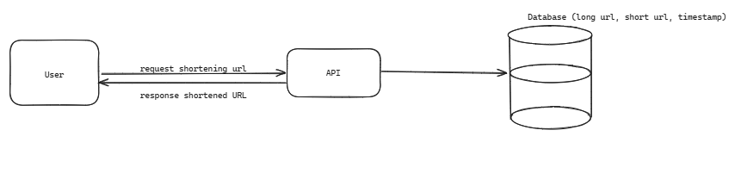
Logical Analysis for Shortening the url:
- SHA-256 produces 256-bit hash. Number of possible hashes: 2^256 ≈ 10^77
This is astronomically larger than 1 billion(10^9)
- Similarly, MD5 produces 2^128 ≈3.4×10^38 >>> 10^9. So, capacity is not the issue.
SHA256 gives unique value with 64 hexadecimal characters.
3f79bb7b435b05321651daefd374cdc681dc06faa65e374e38337b88ca046dea
Much longer than the original short URL we want.

If we truncate the hash :
16^6 ~ 16 million possibilities
Which is nowhere near enough for 1 Billion URLs,
If we keep 8 hex characters
16^8 ≈ 4.29 billion
Now capacity is enough, but collisions become increasingly likely due to the birthday paradox.

- Base62 is better choice for generating 6-7 digit code with 62(0-9,a-z,A-z).
Considering the current write throughput of approximately 3 QPS, an auto-increment ID is simple and sufficient. If the service later scales to thousands of writes per second, or if we shard the database or deploy multiple primary databases, I would replace the centralized sequence with a distributed ID generator such as Snowflake. The Base62 encoding layer remains unchanged because it only converts the generated unique ID into a compact, URL-friendly string

High Level Design
